

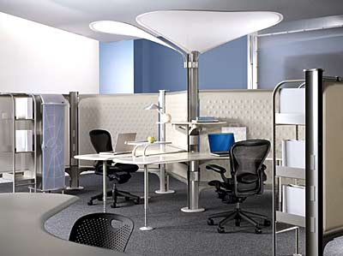

Carpet The most common floor surface, often the most overlooked. And, the least expensive to maintain. Because carpet is the only three-dimensional floor covering, it soils from the bottom to the top. Spills and soil can remain hidden and trapped. Once the carpet is full (saturated) with soil, full restoration may be required. Prevent costly carpet restoration with an economical carpet care program. Regularly maintain heavy traffic areas and extend the life and the look of your carpeting.

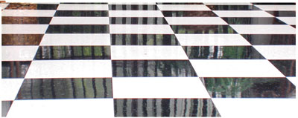

VCT & Resilient Floors Second in popularity to carpet, VCT and resilient floors require special care. FloorCare Specialists has an exclusive line of VCT and Resilient floor care products engineered to deliver longer lasting, harder, more slip resistant, glossier floors than conventional cleaning products. Nothing better reflects your image than a high gloss on a tile floor. We provide maintenance programs, restorative cleaning and daily services for all VCT and resilient floors.

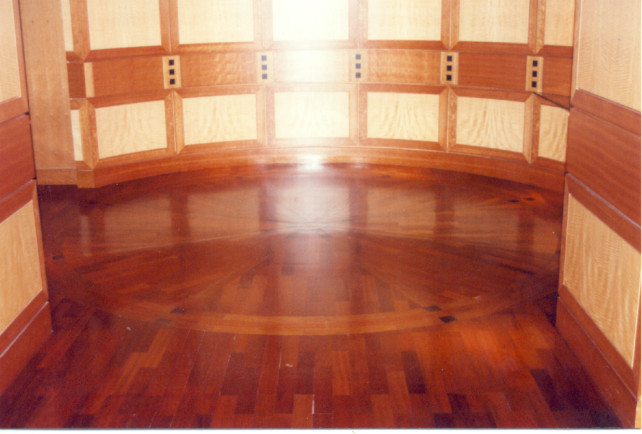

Wood Floors No other floor covering projects a high profile more than the warmth of a quality hard wood floor. Maintaining the depth of finish is important in protecting the aesthetic quality and integrity of your wood. Scuffs and scratches can be easily removed and repaired when a quality finish is applied. Without the right finish, repairs can be costly. FloorCare Specialists utilizes special products designed to protect and enhance the finish and quality of your wood.

Stone Maintenance & Restoration Nothing says “Welcome” more than a properly finished stone floor. Stone floors require special technical knowledge and skills; and the proper equipment and maintenance products. A quality finish cannot be rushed: Care and attention to detail are required. FloorCare Specialists represents an exclusive line of stone maintenance and restoration products. Our highly trained technicians understand the nature of stone floor care.
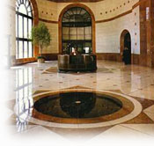

We provide free on site test cleanings, demonstrations & consultations. Give us a challenge!

FloorCare Specialists, 11080 Old Roswell Road, Suite 111, Alpharetta, GA 30006 Ph (678) 802-6020, Fax (678) 802-6021, www.FloorCareSpecialists.com

